SQL ALTER DATABASE

📌 Purpose:
# Source: AI Source: Provided by: [Data Path: Persons Table -> ID Column: 1, Name_En Column: Motasem Essam] -> From: [ChatGPT] on [6/11/2026]
The ALTER DATABASE statement is used to change settings of an existing database, such as its default character set, collation, or other configuration options.

✅ Syntax:
# Source: AI Source: Provided by: [Data Path: Persons Table -> ID Column: 1, Name_En Column: Motasem Essam] -> From: [ChatGPT] on [6/11/2026]
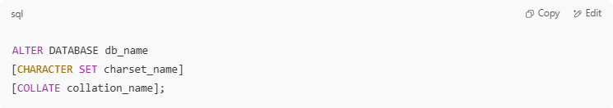
ALTER DATABASE db_name
[CHARACTER SET charset_name]
[COLLATE collation_name];

🧪 Example 1: Change Character Set and Collation
# Source: AI Source: Provided by: [Data Path: Persons Table -> ID Column: 1, Name_En Column: Motasem Essam] -> From: [ChatGPT] on [6/11/2026]
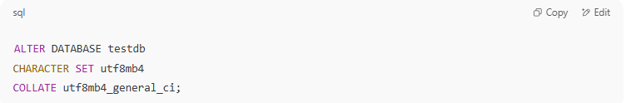
ALTER DATABASE testdb
CHARACTER SET utf8mb4
COLLATE utf8mb4_general_ci;

🔍 This sets the default character set and collation for new tables in testdb.

🧪 Example 2: Change Only Collation
# Source: AI Source: Provided by: [Data Path: Persons Table -> ID Column: 1, Name_En Column: Motasem Essam] -> From: [ChatGPT] on [6/11/2026]
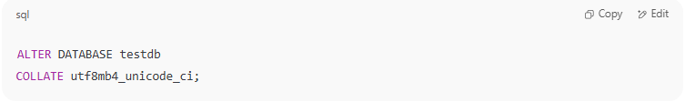
ALTER DATABASE testdb
COLLATE utf8mb4_unicode_ci;

⚠️ Notes:
# Source: AI Source: Provided by: [Data Path: Persons Table -> ID Column: 1, Name_En Column: Motasem Essam] -> From: [ChatGPT] on [6/11/2026]
- Changing character set/collation does not affect existing tables or data.
- You need appropriate privileges (e.g., ALTER, CREATE, SUPER) to run this command.
- This command affects only the default settings used when creating new tables in the database.

📘 How to Check the Current Settings:
# Source: AI Source: Provided by: [Data Path: Persons Table -> ID Column: 1, Name_En Column: Motasem Essam] -> From: [ChatGPT] on [6/11/2026]
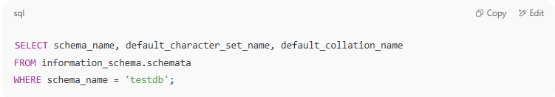
SELECT schema_name, default_character_set_name, default_collation_name
FROM information_schema.schemata
WHERE schema_name = 'testdb';

Let me know if you want to include character set types, collation rules, or examples showing effects when creating new tables.

Example

prepared commands
# Source: ScreenShot Source: Provided by: [Persons Table -> ID Column: 1, Name_En Column: Motasem Essam] -> Tool: [Automation Table -> ID Column: 16, Name_En Column: Screen Capture] -> From [Operating System: Wampserver64 -> phpmyadmin] on [6/11/2026]
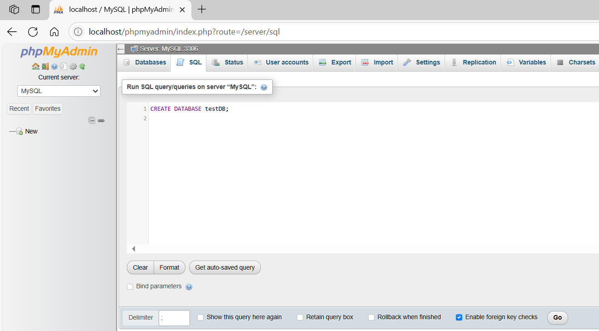
CREATE DATABASE testDB;
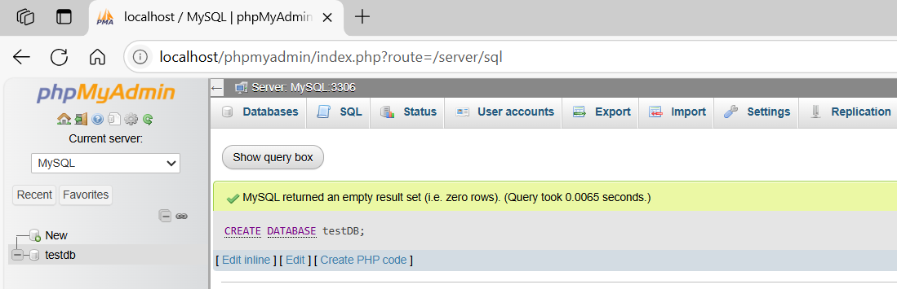
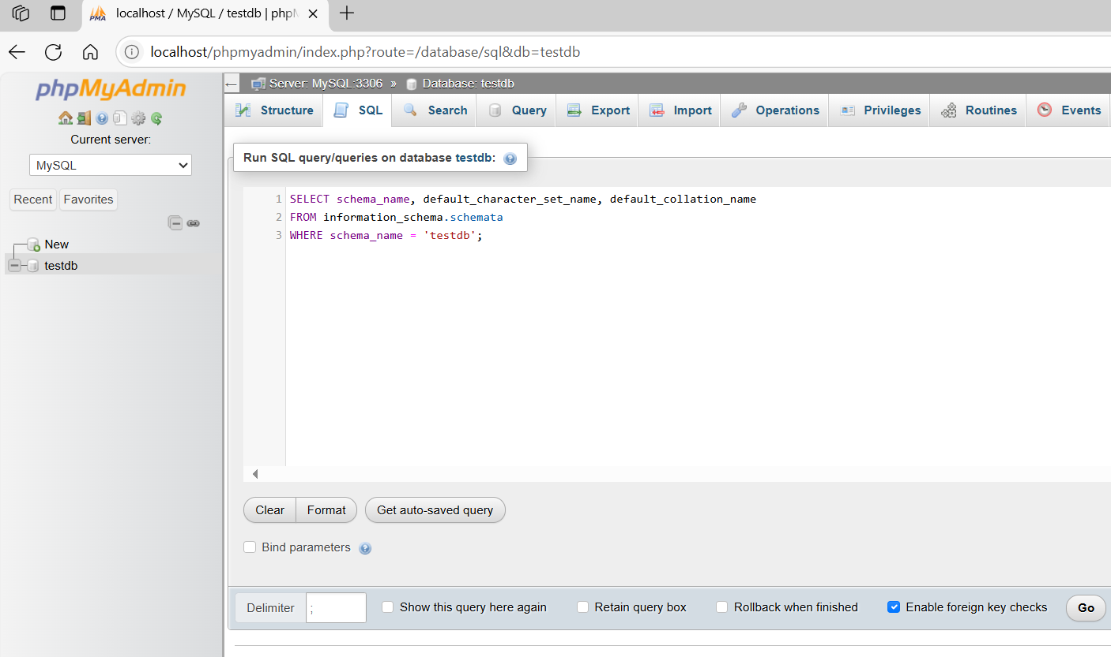
SELECT schema_name, default_character_set_name, default_collation_name
FROM information_schema.schemata
WHERE schema_name = 'testdb';
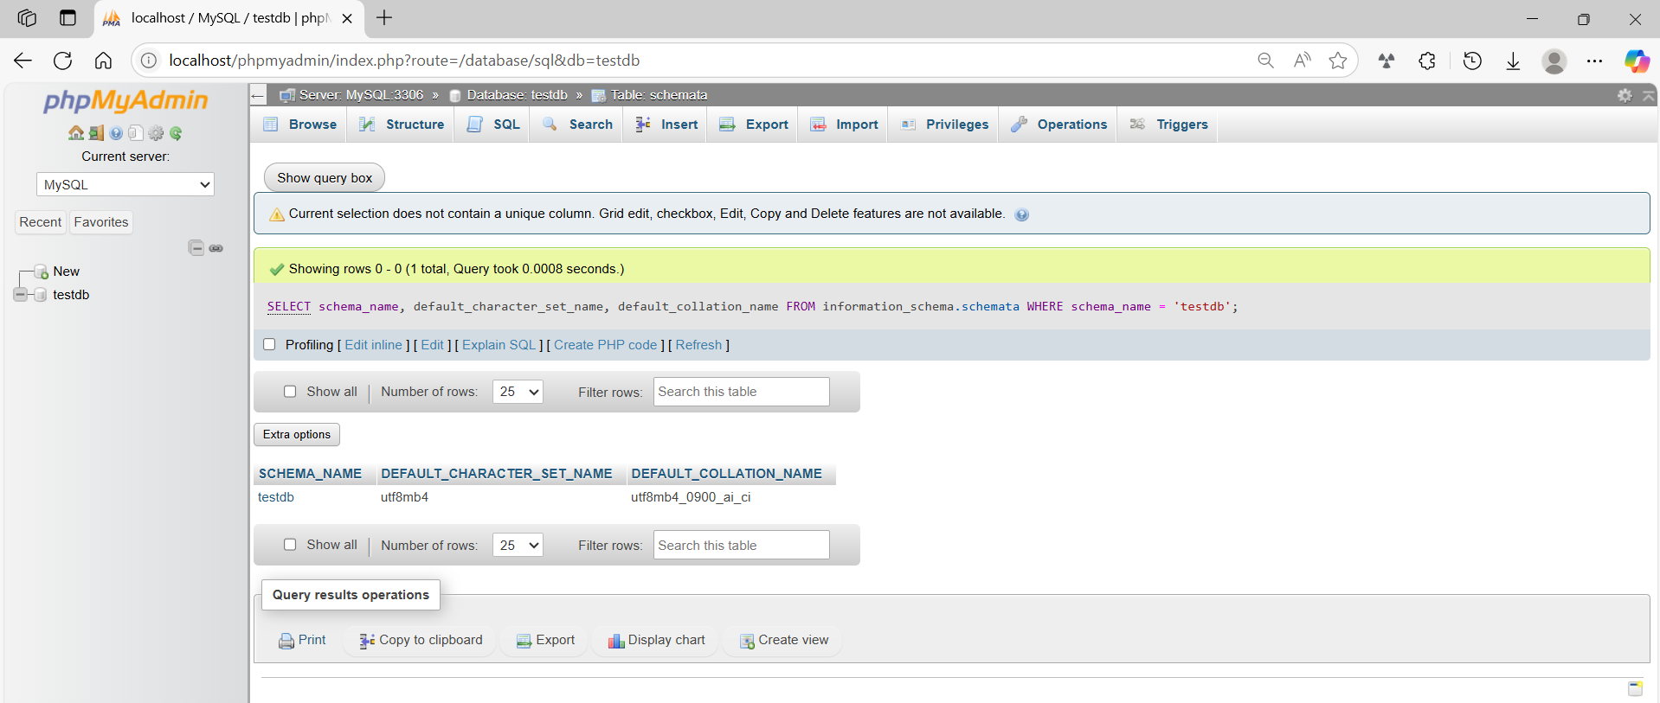

basic command
# Source: ScreenShot Source: Provided by: [Persons Table -> ID Column: 1, Name_En Column: Motasem Essam] -> Tool: [Automation Table -> ID Column: 16, Name_En Column: Screen Capture] -> From [Operating System: Wampserver64 -> phpmyadmin] on [6/11/2026]
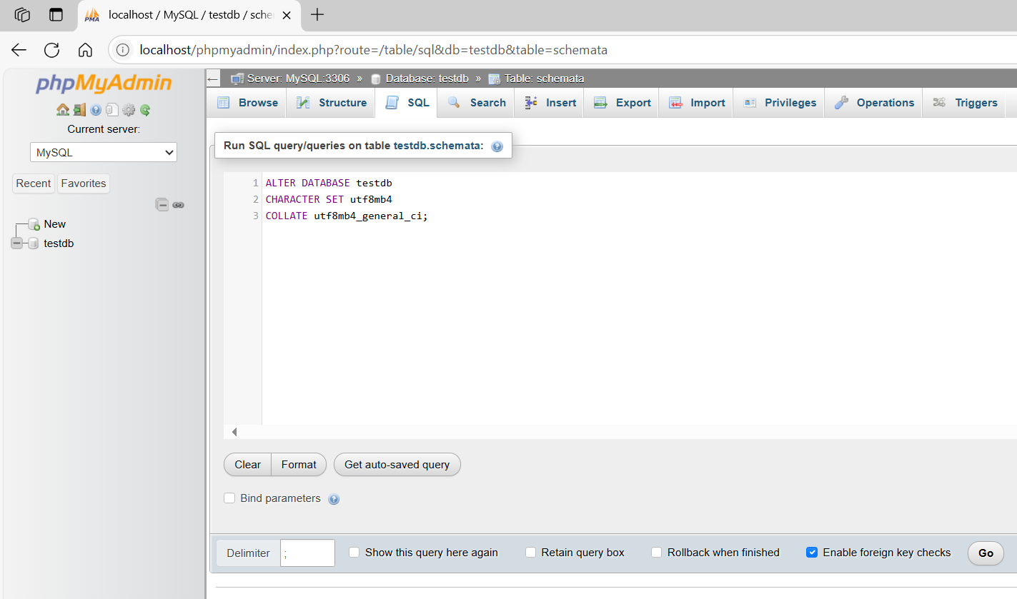
ALTER DATABASE testdb
CHARACTER SET utf8mb4
COLLATE utf8mb4_general_ci;
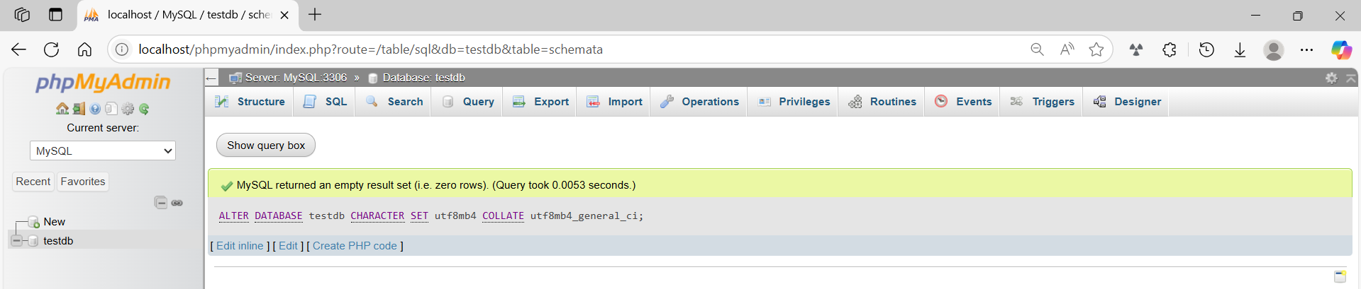
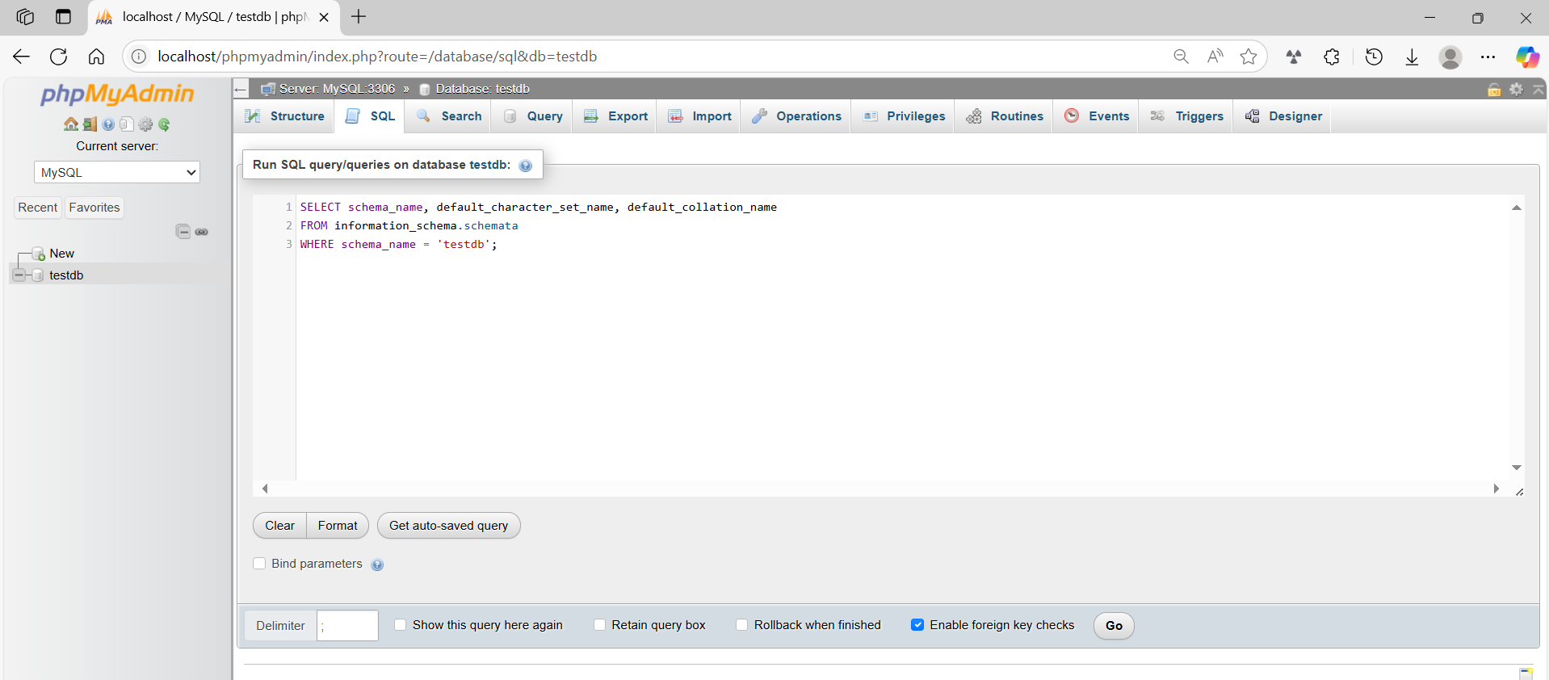
SELECT schema_name, default_character_set_name, default_collation_name
FROM information_schema.schemata
WHERE schema_name = 'testdb';
